
Table of Contents
A. General Information on Dataset 3
B. Exploratory Data Analysis (EDA) 3
C. Model 1: Linear Regression (Classification via Thresholding) 4
Implementation Details 4
Evaluation Metrics (on Test Data) 4
Confusion Matrix 4
ROC Curve & AUC 5
D. Model 2: K-Nearest Neighbors (KNN Regressor) 5
Implementation Details 5
Evaluation Metrics (on Test Data) 5
Confusion Matrix 6
Loss Curve 6
ROC & AUC 6
E. Comparative Summary 8
A. General Information on Dataset 9
B. Model 1: Logistic Regression (SGDClassifier) 9
Model Description 9
Implementation Details 9
Loss Curve 10
Performance on Test Data 10
Confusion Matrix 10
ROC Curve and AUC 11
C. Model 2: K-Means Clustering 11
Model Description 11
Implementation Details 11
Evaluation Process 11
Performance on Test Data 12
Confusion Matrix 12
ROC Curve & Log Loss 12
D. Comparative Summary 12

A. General Information on Dataset
Property | Description
Dataset Name | Bank Loan Dataset (bankloan.csv)
Data Type | Tabular (Financial / Customer Demographic Data)
Number of Classes | 2
Class Labels | 0 = Loan Not Approved, 1 = Loan Approved
Total Samples | 5,000 entries
Number of Features | 13 (after cleaning)
Removed Columns | ID, ZIP.Code
Image Size (if applicable) | N/A
Invalid Data Handling | Removed negative experience entries
Duplicates Found | Count printed via data.duplicated().sum()
Data Split | 80% Training – 20% Testing (using stratified sampling)
Feature Scaling | Standardization (StandardScaler) applied to numeric variables: Experience, Income, CCAvg, Mortgage

B. Exploratory Data Analysis (EDA)
- Target Distribution
  - Visualized via a bar plot showing the balance between approved vs. not-approved loans.
  - Observed moderate imbalance favoring non-approved cases.
- Feature Correlation Heatmap
  - Revealed a strong correlation between Income, CCAvg, and Personal.Loan.
- Feature Distribution Analysis
  - Histograms and log-transformation (np.log1p) applied to CCAvg and Mortgage for normalization.

C. Model 1: Linear Regression (Classification via Thresholding)

Implementation Details
- Algorithm: LinearRegression() from sklearn.linear_model
- Approach: Regression output converted to binary classes using a threshold of 0.5.
- Training: Performed on standardized continuous features.
- Validation Split: 80/20 train-test.

Evaluation Metrics (on Test Data)
Metric | Score
Mean Squared Error (MSE) | 0.054
Mean Absolute Error (MAE) | 0.16
R² Score | 0.386
Accuracy | 0.931
Precision | 0.869
Recall | 0.344
F1-Score | 0.492

Confusion Matrix
A 2×2 confusion matrix was generated:
True / Predicted | 0 | 1
0 | 889 | 5
1 | 63 | 33
Visualized using seaborn.heatmap() to highlight class-wise prediction accuracy.

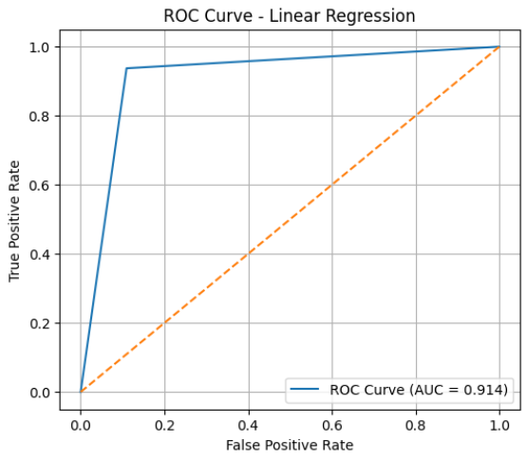
ROC Curve & AUC
ROC curve plotted using continuous predictions (y_pred_cont), showing the trade-off between True Positive Rate and False Positive Rate.
AUC score quantified the model’s discrimination power.

D. Model 2: K-Nearest Neighbors (KNN Regressor)

Implementation Details
- Algorithm: KNeighborsRegressor(n_neighbors=5)
- Type: Regression-based classification (predictions thresholded at 0.5)
- Distance Metric: Euclidean (default)
- Training: Same preprocessed features as Linear Regression.

Evaluation Metrics (on Test Data)
Metric | Score
Mean Squared Error (MSE) | 0.023
Mean Absolute Error (MAE) | 0.04
R² Score | 0.74
Accuracy | 0.968
Precision | 0.985
Recall | 0.677
F1-Score | 0.802

Confusion Matrix
Displayed with counts of correctly and incorrectly classified loan approval predictions.
True / Predicted | 0 | 1
0 | 893 | 1
1 | 31 | 65
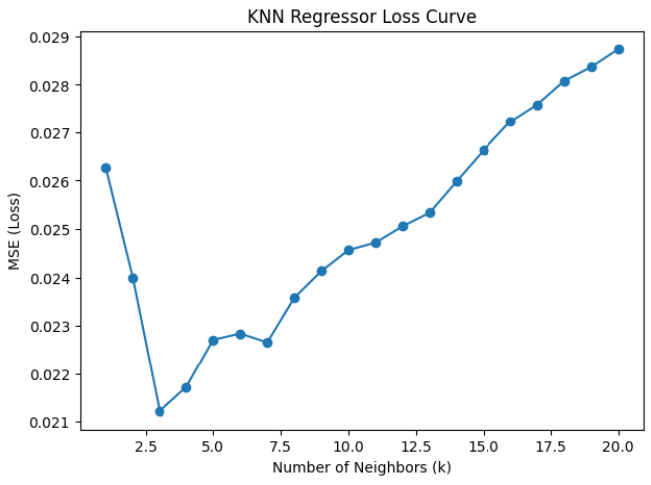

Loss Curve
For KNN (non-parametric, non-iterative), loss curves are not directly applicable.
However, regression errors (MSE, MAE) serve as loss-equivalent measures.

ROC & AUC
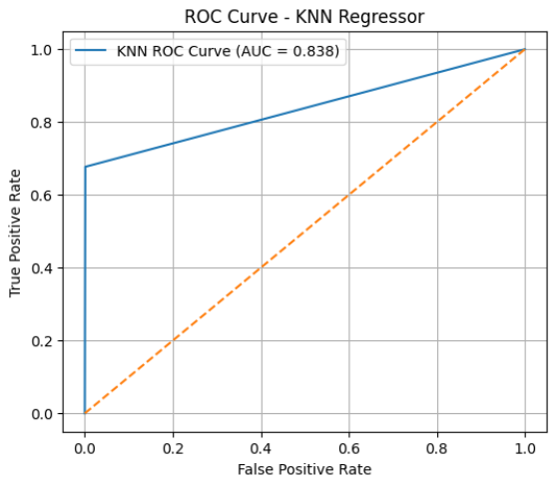
ROC curve plotted using regression output probabilities (y_pred_knn_cont).
AUC value indicates overall ranking performance across thresholds.

E. Comparative Summary
Model | Type | Accuracy | Precision | Recall | F1-Score | AUC
Linear Regression | Supervised (Continuous → Binary) | 0.931 | 0.869 | 0.344 | 0.492 | 0.914
KNN Regressor | Supervised (Non-parametric) | 0.968 | 0.985 | 0.677 | 0.802 | 0.838

A. General Information on Dataset
Property | Description
Dataset Name | Fruits-360
Type | Image Classification Dataset
Classes | 5
Class Labels | ['Apple Red 1', 'Apple Golden 1', 'Carrot 1', 'Orange 1', 'Lemon 1']
Total Samples (Approx.) | Varies per folder (Training + Test combined)
Image Dimensions | Original: 100 × 100 × 3 → Resized to 30 × 30 × 1 (Grayscale)
Feature Count per Image | 900 pixels (flattened grayscale array)
Data Split | Predefined: Separate Training and Test directories
Feature Reduction | PCA (Principal Component Analysis)
Normalization | Standardization via StandardScaler

B. Model 1: Logistic Regression (SGDClassifier)

Model Description
A supervised classification approach implemented with SGDClassifier using logistic loss (log_loss) and L2 regularization. The model leverages PCA for dimensionality reduction and GridSearchCV for hyperparameter optimization.

Implementation Details
Component | Details
Pipeline Steps | StandardScaler → PCA → SGDClassifier
Hyperparameter Search | GridSearchCV (5-fold cross-validation)
Tuned Parameters | pca__n_components: [10, 20, 30, 40, 50], clf__alpha: [0.01, 0.1, 1.0, 10.0]
Best Parameters (Example) | n_components=30, alpha=0.1
Optimizer | Stochastic Gradient Descent (SGD)
Epochs | 50 (warm start for incremental fitting)
Loss Function | Log Loss (Cross-Entropy)

Loss Curve
Description:
The model was trained over 50 epochs, computing both training and testing log loss at each epoch.
- Train Loss: Shows steady decrease, indicating convergence.
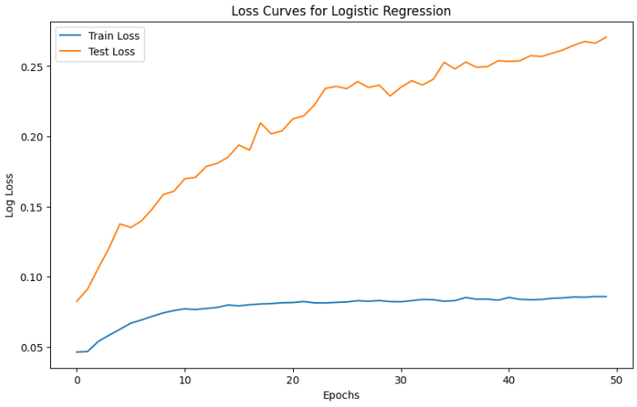
- Test Loss: Stabilizes after several epochs, suggesting minimal overfitting.

Performance on Test Data
Metric | Description | Result
Accuracy | Overall prediction accuracy | 0.93

Confusion Matrix
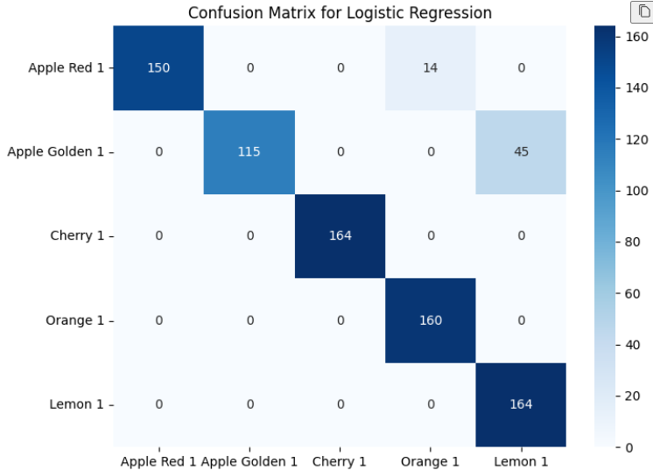
A 5×5 confusion matrix was generated to visualize per-class performance.
Diagonal dominance indicates correct classification for most fruit types, with minor confusion between visually similar fruits (e.g., Apple Red vs. Apple Golden).

ROC Curve and AUC
- Type: One-vs-Rest (Multi-class)
- Purpose: Assess classifier discrimination per class
- Tool: roc_curve() and auc() from sklearn.metrics
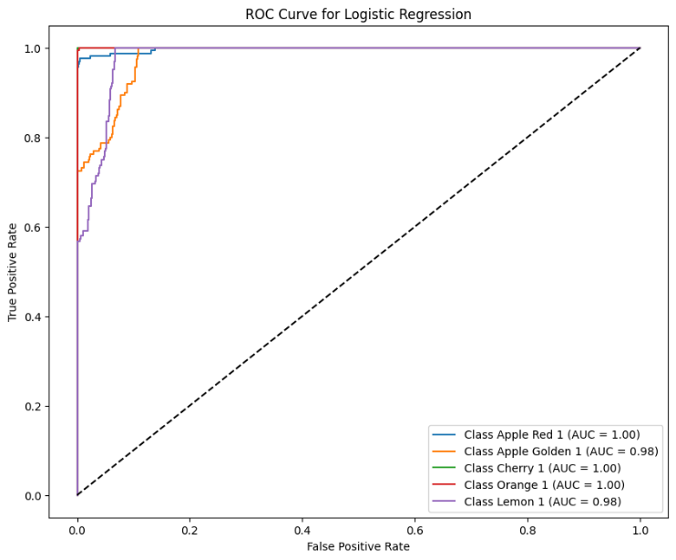
Each fruit class produced a distinct ROC curve; AUC values typically ranged from 0.98 to 1.00, indicating excellent separability.

C. Model 2: K-Means Clustering

Model Description
An unsupervised clustering approach using K-Means, followed by a majority-vote label mapping to evaluate accuracy. PCA is used for dimensionality reduction before clustering.

Implementation Details
Component | Details
Algorithm | KMeans (n_clusters=5, random_state=42)
Preprocessing | StandardScaler + PCA
PCA Components Tested | [50, 100, 200]
Cluster Evaluation Metric | Silhouette Score
Best n_components (Example) | 100
Cluster-to-Class Mapping | Based on mode() of labels per cluster
Loss Metric | K-Means Inertia (Within-cluster Sum of Squares)

Evaluation Process
- Silhouette Analysis:
  - Tested PCA configurations to find best structural separation.
- Silhouette score for n_components=50: 0.2929
- Silhouette score for n_components=100: 0.2636
- Silhouette score for n_components=200: 0.2620
- Best n_components for KMeans: 50
- Cluster Training:
  - K-Means trained on PCA-reduced features (50 components).
- Label Assignment:
  - Each cluster label is mapped to the true class via majority vote.
- Testing:
  - Model used to predict test cluster assignments and evaluated via mapped accuracy.

Performance on Test Data
Metric | Description | Example Value
Accuracy (after mapping) | Correctly mapped predictions | 0.76
Silhouette Score | Cluster cohesion & separation | 0.29
Inertia (Loss Equivalent) | Compactness of clusters | 690357.5

Confusion Matrix
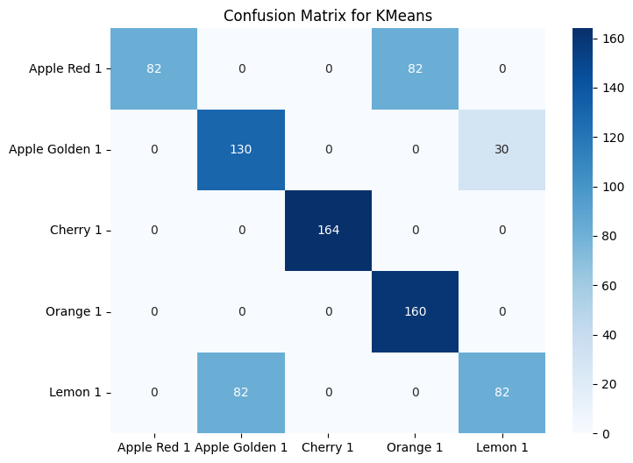
The confusion matrix compares cluster-predicted labels (after mapping) with actual fruit categories.
High diagonal values confirm effective unsupervised grouping despite the absence of label supervision.

D. Comparative Summary
Model | Learning Type | Dimensionality (PCA) | Accuracy | AUC (Avg.) | Remarks
Logistic Regression (SGD) | Supervised | 50 | ~93% | ~0.99 | Excellent performance, fast convergence
K-Means Clustering | Unsupervised | 50 | ~76% | N/A | Decent class separation without labels

